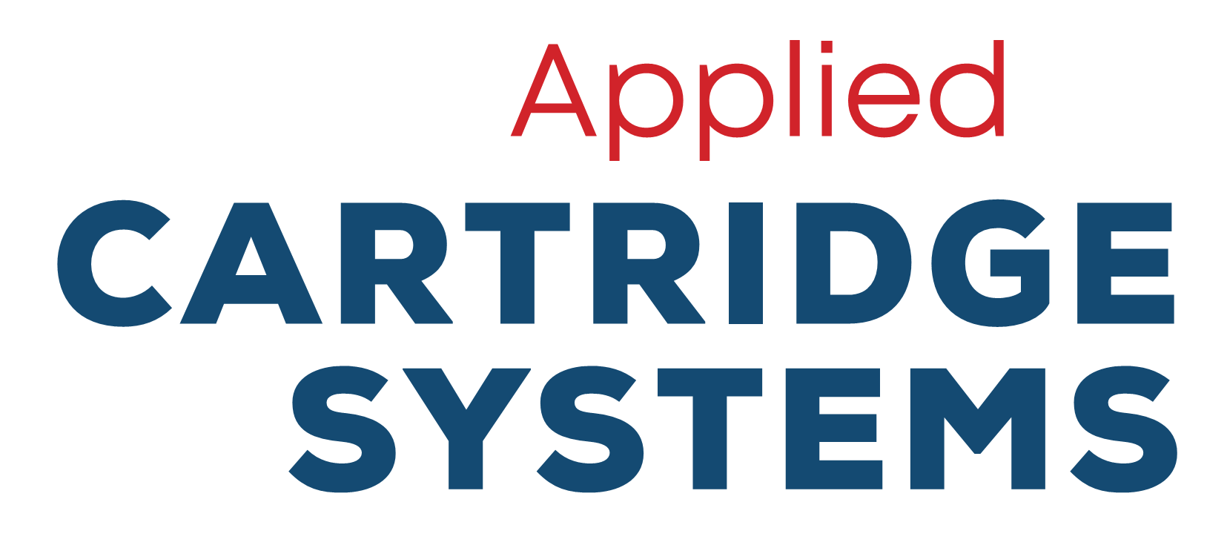
PRODUCT SPECIFICATIONS
7 STANDARD SIZES | STAINLESS STEEL CONSTRUCTION
Model: | 5 GPM  ISO-5-SS | 10 GPM  ISO-10-SS | 15 GPM  ISO-15-SS | 20 GPM  ISO-20-SS | 25 GPM  ISO-25-SS | 50 GPM  ISO-50-SK | 100 GPM  ISO-100-SK
Max. Flow Rate: | 5 gpm | 10 gpm | 15 gpm | 20 gpm | 25 gpm | 50 gpm | 100 gp
No# of Vessels: | 1 | 1 | 1 | 1 | 1 | 2 on skid | 4 on skid
No# of Cartridges: | 1 | 2 | 3 | 4 | 5 | 10 | 20
Maintenance: | NO BACKWASHING REQUIRED!
Pre-filter: (included) | 10” 1-micron  cartridge filter  Polypropylene | 20” 1-micron  cartridge filter  Polypropylene | 20” 1-micron  bag filter  Polypropylene | 20” 1-micron  bag filter  Polypropylene | 1-micron, 1 bag  bag filter  Stainless Steel | 1-micron, 1 bag  cartridge filter  Stainless Steel | 1-micron, 3 bag  cartridge filter  Stainless Steel
Vessel Size: | 6.5” OD x 53” H | 10” OD x 58” H | 10” OD x 58” H | 12” OD x 58” H | 14” OD x 67-3/8” H | NA | NA
Vessel Construction: | 100 psi, 304 SS | 100 psi, 304 SS | 100 psi, 304 SS | 100 psi, 304 SS | 150 psi, 304 SS | 150 psi, 304 SS | 150 psi, 304 SS
Cartridge Size: | 4.5” OD x 42” L | 4.5” OD x 42” L | 4.5” OD x 42” L | 4.5” OD x 42” L | 4.5” OD x 42” L | 4.5” OD x 42” L | 4.5” OD x 42” L
Shipping Weight: | 27 lbs. | 71 lbs. | 71 lbs. | 105 lbs. | 330 lbs. | 675 lbs. | 1,200 lbs.
Inlet/Outlet Connection: | 1.5” FPT | 1.5” FPT | 1.5” FPT | 2” FNPT | 2” ASME Flange | 2” ASME Flange | 3” ASME Flange
System Footprint: | 10”L x 10”D x 53”H | 15”L x 15”D x 59”H | 15”L x 15”D x 59”H | 18”L x 18”D x 59”H | 22”L x 22”D x 67”H | 64”L x 18”D x 75”H | 58”L x 39”D x 75”H
Headroom Requirement: | 82” | 84” | 84” | 84” | 108” | 120” | 120”

