**HCP AF Series Submersible Sewage Pumps Technical Data and Specifications**

**Specifications**

|  |  |  |  |
| --- | --- | --- | --- |
| **Discharge (in):** | 2 – 14” *(Optional 16”)* | **MATERIALS:** | |
| **Liquid Temp Limits:** | 32˚ - 104˚ F | **Upper Cover:** | ASTM-48, Class 30 |
| **Submersion Depth:** | 100 ft | **Motor Frame:** | ASTM-48, Class 30 |
| **Frequency:** | 60 Hz | **Main Shaft:** | SUS420J2, SUS403, SUS410 |
| **Motor:** | 3600 RPM (2P)  Dry Motor | **Mechanical Seal:** | UPPER: Carbon/Ceramic  LOWER: Silicon/Silicon |
| **Insulation:** | Class B (5 hp Class F) | **Casing:** | ASTM-48, Class 30 |
| **Protection:** | IP68 | **Impeller:** | ASTM-48, Class 30 |
| **Protector:** | Thermal, Over Temp & Moisture | **Wear Ring:** | Brass |
| **Bearing:** | Ball type | **Cable:** | 30 ft and 50 ft |
| **Mechanical Seal:** | Double |  |  |
| **Impeller:** | **P** – Semi Open/Single Vane  **P** – Semi Open/Two Vane  **U** – Semi Open Vortex  **E** – Enclosed Channel |  |  |

**Performance**

*Product Nomenclature*

|  |  |  |  |  |
| --- | --- | --- | --- | --- |
| **80** | **AF** | **P** | **2** | **7.5** |
| **Discharge (mm)** | **Type** | **Impeller Type** | **Pole** | **kW** |

**2” - 3” Discharge Models**

|  |  |  |  |  |  |  |
| --- | --- | --- | --- | --- | --- | --- |
| **Model**  **Series:** | **Power**  (Hp) | **Discharge**  (in) | **Phase** | MAX | | **Solids**  **Passage**  (in) |
| **Head**  (ft) | **Flow**  (GPM) |
| **50AFU2.4** | 0.5 | 2 | 1 & 3 | 34 | 75 | 1.5 |
| **50AFU2.4L** | 0.5 | 2 | 1 & 3 | 22 | 80 | 2 |
| **50AFU4.4** | 0.5 | 2 | 1 & 3 | 19 | 84 | 2 |
| **50AFU2.8** | 1 | 2 | 1 & 3 | 48 | 97 | 1.5 |
| **50AFU2.8L** | 1 | 2 | 1 & 3 | 34 | 104 | 2 |
| **50AFU4.8** | 1 | 2 | 1 & 3 | 27 | 109 | 2 |
| **50AFU21.5** | 2 | 2 | 1 & 3 | 70 | 114 | 1.5 |
| **80AFP21.5** | 2 | 3 | 1 & 3 | 53 | 268 | 1.5 |
| **80AFP41.5** | 2 | 3 | 1 & 3 | 47 | 260 | 2 |
| **80AFU21.5** | 2 | 3 | 1 & 3 | 53 | 180 | 2 |
| **80AFU21.5L** | 2 | 3 | 1 & 3 | 23 | 186 | 3 |
| **80AFU41.5** | 2 | 3 | 1 & 3 | 29 | 260 | 3 |
| **80AFP22.2** | 3 | 3 | 1 & 3 | 67 | 296 | 1.5 |
| **80AFP42.2** | 3 | 3 | 1 & 3 | 53 | 300 | 2 |
| **80AFU22.2** | 3 | 3 | 1 & 3 | 65 | 115 | 2 |
| **80AFU22.2L** | 3 | 3 | 1 & 3 | 31 | 228 | 3 |
| **80AFU42.2** | 3 | 3 | 1 & 3 | 35 | 296 | 3 |
| **80AFE42.2** | 3 | 3 | 1 & 3 | 39 | 330 | 3 |
| **80AFP23.7A** | 5 | 3 | 1 & 3 | 100 | 354 | 1.25 |
| **80AFP43.7** | 5 | 3 | 3 | 64 | 408 | 2 |
| **80AFU23.7LA** | 5 | 3 | 1 & 3 | 49 | 296 | 3 |
| **80AFU23.7A** | 5 | 3 | 1 & 3 | 81 | 286 | 3 |
| **80AFU43.7** | 5 | 3 | 3 | 47 | 365 | 3 |

**3” - 4” Discharge Models**

|  |  |  |  |  |  |  |
| --- | --- | --- | --- | --- | --- | --- |
| **Model**  **Series:** | **Power**  (Hp) | **Discharge**  (in) | **Phase** | MAX | | **Solids**  **Passage**  (in) |
| **Head**  (ft) | **Flow**  (GPM) |
| **80AFE43.7** | 5 | 3 | 3 | 54 | 410 | 3 |
| **80AFP25.5** | 7.5 | 3 | 3 | 117 | 405 | 1.25 |
| **80AFU25.5** | 7.5 | 3 | 3 | 94 | 328 | 3 |
| **80AFU25.5L** | 7.5 | 3 | 3 | 64 | 640 | 3 |
| **80AFP27.5** | 10 | 3 | 3 | 144 | 450 | 1.25 |
| **80AFU27.5** | 10 | 3 | 3 | 113 | 365 | 3 |
| **80AFU27.5L** | 10 | 3 | 3 | 84 | 397 | 3 |
| **80AFP211** | 15 | 3 | 3 | 178 | 520 | 1.25 |
| **80AFU211** | 15 | 3 | 3 | 137 | 380 | 2 |
| **80AFU211L** | 15 | 3 | 3 | 114 | 460 | 3 |
| **100AFE42.2** | 3 | 4 | 3 | 42 | 462 | 3 |
| **100AFE43.7** | 5 | 4 | 3 | 58 | 582 | 3 |
| **100AFU45.5** | 7.5 | 4 | 3 | 54 | 575 | 4 |
| **100AFE45.5** | 7.5 | 4 | 3 | 76 | 680 | 3 |
| **100AFU47.5** | 10 | 4 | 3 | 64 | 655 | 4 |
| **100AFE47.5** | 10 | 4 | 3 | 85 | 760 | 3 |
| **AF-415** | 15 | 4 | 3 | 110 | 660 | 2 |

**6” - 16” Discharge Models**

|  |  |  |  |  |  |  |
| --- | --- | --- | --- | --- | --- | --- |
| **Model**  **Series:** | **Power**  (Hp) | **Discharge**  (in) | **Phase** | MAX | | **Solids**  **Passage**  (in) |
| **Head**  (ft) | **Flow**  (GPM) |
| **AF-610** | 10 | 6 | 3 | 67 | 1120 | 3 |
| **AF-615** | 15 | 6 | 3 | 85 | 1460 | 3 |
| **AF-620** | 20 | 6 | 3 | 120 | 1560 | 3 |
| **AF-815** | 15 | 8 | 3 | 58 | 2010 | 3 |
| **AF-820** | 20 | 8 | 3 | 75 | 2360 | 3 |
| **AF-1030S** | 30 | 10 | 3 | 97 | 3075 | 2.25 |
| **AF-1040** | 40 | 10 | 3 | 112 | 3115 | 2.25 |
| **AF-1050** | 50 | 10 | 3 | 126 | 3500 | 2.25 |
| **AF-1060** | 60 | 10 | 3 | 135 | 3525 | 2.25 |
| **AF-1430** | 30 | 14 | 3 | 47 | 5800 | 5 |
| **AF-1440** | 40 | 14 | 3 | 55 | 6450 | 5 |
| **AF-1650** | 50 | 16 | 3 | 57 | 6600 | 5 |
| **AF-1660** | 60 | 16 | 3 | 66 | 7250 | 5 |

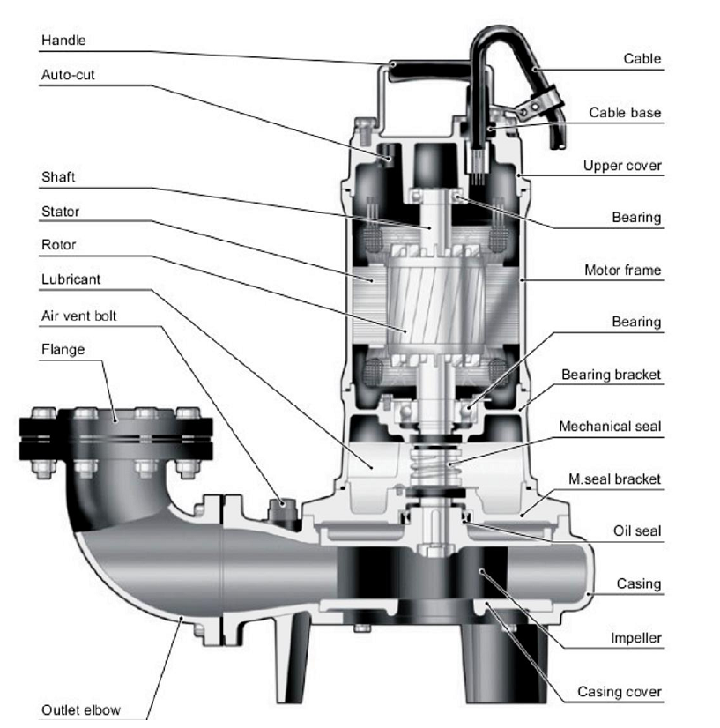

|  |  |
| --- | --- |
| 9332 North 95th Way  Scottsdale, AZ 85258  ***Phone:480-998-4097***  [sales@apewater.com](mailto:sales@apewater.com) |  |