HCP GF Series Submersible Grinder Pumps Technical Data and Specifications
Specifications
Discharge (in): | 1.25 - 3” | MATERIALS:
Liquid Temp Limits: | 32˚ - 104˚ F | Upper Cover: | ASTM-48, Class 30
Submersion Depth: | 100 ft | Motor Frame: | ASTM-48, Class 30
Frequency: | 60 Hz | Main Shaft: | SUS403
Motor: | 3600 RPM – (2P)  Dry Motor | Mechanical Seal: | UPPER: Carbon/Ceramic  LOWER: Silicon/Silicon
Insulation: | Class B (5 hp Class F) | Casing: | ASTM-48, Class 30
Protection: | IP68 | Impeller: | ASTM-48, Class 30
Protector: | Auto-cut | Radial Cutter: | SUS440C
Bearing: | Ball type | Cutter Ring: | SUS440C
Mechanical Seal: | Double | Cable: | VCT or H07RN-F or SJOW/SOW
Impeller: | Vortex

Performance
Product Nomenclature
32 | GF | 2 | 1.5
Discharge (mm) | Type | Pole | kW

Model  Series: | Power  (Hp) | Discharge  (in) | Phase | MAX
 |  |  |  | Head  (ft) | Flow  (GPM)
32GF0.75 | 1/.75 | 1.25 | 1/3 | 63 | 35
32GF21.0 | 1.3/1 | 1.25 | 1/3 | 68 | 33
32GF21.0-2A | 1.3/1 | 1.25 | 1/3 | 72 | 66
32GF21.5 | 2/1.5 | 1.25 | 1/3 | 85 | 38
32GF21.5-2A | 2/1.5 | 1.25 | 1/3 | 78 | 66
32GF22.2 | 3/2.2 | 1.25 | 1/3 | 108 | 44
32GF22.2H | 3/2.2 | 1.25 | 1/3 | 132 | 36
32GF22.2-2M | 3/2.2 | 1.25 | 3 | 60 | 98
32GF23.0-2M | 4/3.0 | 1.25 | 3 | 85 | 110
32GF23.0-2H | 4/3.0 | 1.25 | 3 | 98 | 90
50GF22.2 | 3/2.2 | 2 | 3 | 82 | 85
50GF23.7 | 5/3.7 | 2 | 3 | 120 | 88
50GF24.02M | 5.3/4.0 | 2 | 3 | 98 | 145
50GF24.0-2H | 5.3/4.0 | 2 | 3 | 138 | 70
50GF25.5 | 7.5/5.5 | 2 | 3 | 145 | 91
50GF27.5 | 10/7.5 | 2 | 3 | 177 | 87
80GF25.5-2M | 7.5/7.5 | 3 | 3 | 82 | 286
80GF25.5-2H | 7.5/7.5 | 3 | 3 | 110 | 145
80GF27.5-2M | 10/7.5 | 3 | 3 | 105 | 286
80GF27.5-2H | 10/7.5 | 3 | 3 | 140 | 160

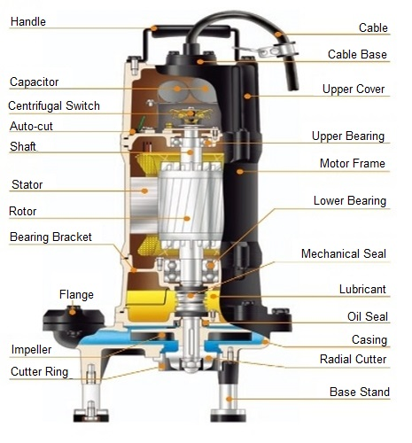

9332 North 95th Way
Scottsdale, AZ 85258
Phone:480-998-4097
sales@apewater.com

