HCP SS/SF Series Stainless Steel Submersible Pumps Technical Data and Specifications
Specifications
Discharge (in): | 2 – 3” | MATERIALS:
Liquid Temp Limits: | 32˚ - 104˚ F | Upper Cover: | SCS14
Submersion Depth: | 100 ft | Motor Frame: | SUS316
Frequency: | 60 Hz | Main Shaft: | SUS316
Motor: | 3600 RPM – (2P)  Dry Motor | Mechanical Seal: | UPPER: Carbon/Ceramic  LOWER: Silicon/Silicon
Insulation: | Class B (5 hp Class F) | O-Ring: | Viton
Protection: | IP68 | Casing: | SCS13 (0.5 hp), SCS14
Protector: | Auto-cut | Impeller: | SCS14
Bearing: | Ball type | Cable: | VCT or H07RN-F or SJOW/SOW
Mechanical Seal: | Double
Impeller: | Semi-open

Performance
Model  Series: | Power  (Hp) | Discharge  (in) | Phase | MAX |  | Solids  Passage  (in)
 |  |  |  | Head  (ft) | Flow  (GPM)
SS-05A | 0.5 | 2 | 1/3 | 37 | 60 | 0.5
SS-21A | 1 | 2 | 1/3 | 50 | 88 | 0.5
SF-05AU | 0.5 | 2 | 1/3 | 32 | 70 | 1.5
SF-21AU | 1 | 2 | 3 | 45 | 95 | 1.5
80SFU21.5 | 2 | 3 | 3 | 26 | 105 | 2
80SFU22.2 | 3 | 3 | 3 | 41 | 105 | 2
80SFU23.7 | 5 | 3 | 3 | 58 | 132 | 2
80SFU25.5 | 7.5 | 3 | 3 | 101 | 332 | 2
80SFU27.5 | 10 | 3 | 3 | 122 | 360 | 2
80SFP21.5 | 2 | 3 | 3 | 26 | 160 | 1.5
80SFP22.2 | 3 | 3 | 3 | 41 | 160 | 1.5
80SFP23.7 | 5 | 3 | 3 | 68 | 150 | 1.5
80SFP25.5 | 7.5 | 3 | 3 | 120 | 398 | 1.5
80SFP27.5 | 10 | 3 | 3 | 145 | 452 | 1.5
100SFP25.5 | 7.5 | 4 | 3 | 119 | 460 | 2
100SFP27.5 | 10 | 4 | 3 | 145 | 540 | 2

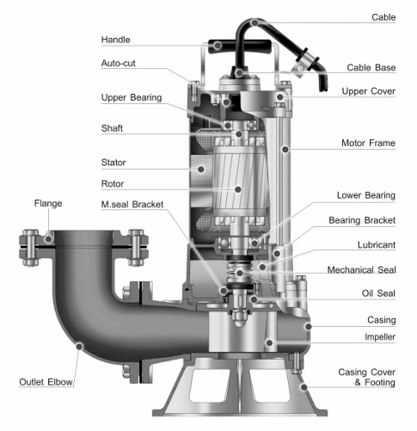

9332 North 95th Way  Scottsdale, AZ 85258  Phone:480-998-4097  sales@apewater.com | 