(linked from CIG Gear Pumps SPECIFICATIONS)
IMO CIG Gear Pumps are designed for low noise levels, high reliability and long life

IMO CIG (Crescent Internal Gear) gear pumps are available in multiple stages for very high pressure or moderate pressure on very low viscosity fuels. The patented tooth profile of IMO CIG gear pumps avoids trapping fluid. The result is a very low pulsation, extremely quiet high efficiency pump.

Pumps are available in single or double pump configurations. Single pump flow rates run from 1 to 125 GPM with continuous pressure ratings to 4000 PSIG. Double Pumps share a common inlet port but deliver two independent flows for supporting multiple machine functions.

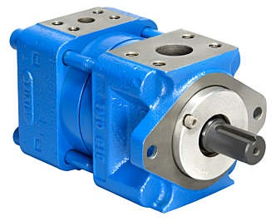
See CIG Gear Pump Dimensions & Drawings
See CIG Pump Specifications Chart
CIG Gear Pump Model Flow & Pressure Ranges
CIG Model: Flow Range: GPM @ 1750 RPM** Pressure Range: PSI**  2_*005 1.1 1000 - 4000  2_006 1.6 1000 - 4000  2_008 2.3 1000 - 4000  3_010 2.9 1000 - 4000  3_012 3.7 1000 - 4000  3_016 5.3 1000 - 4000  4_020 7.2 1000 - 4000  4_025 9.3 1000 - 4000  4_032 12.2 1000 - 4000  5_040 15.3 1000 - 4000  5_050 20.1 1000 - 4000  5_063 26.1 1000 - 4000  6_080 32.1 1000 - 4000  6_100 41.9 1000 - 4000  6_125 52.1 1000 - 4000  8_160 67.4 1000 - 4000  8_200 83.5 1000 - 4000  8_250 105.1 1000 - 4000  * Insert Pressure Rating Number from Model Key  ** Capable of running at higher or lower speeds and at higher pressures | IMO Gear Pump Model Key  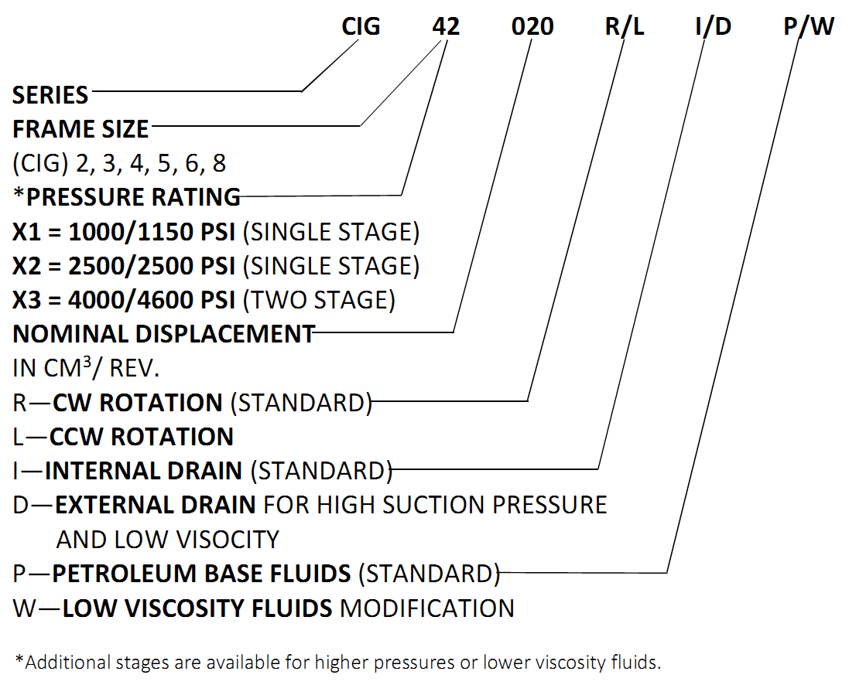

The unique characteristic of the CIG Gear Pump design is the patented gear tooth profile. Tooth flanks on the pinion are essentially straight which practically eliminates any trapped oil volume. Pressure pulsations are eliminated resulting in ripple-free, low noise operation.
There are only two moving parts per stage. They consist of a single shaft that runs through the center of the pump housing driving a pair of star shaped gears for each stage or element of the pump. A tie rod design allows the “stacking of these modular stages for increased pressure ratings.
The self-priming CIG gear pumps have extra-large suction and discharge areas. There is normally no need for a booster pump even at high rotational speeds. They are capable of handling a broad range of fluids with low or high viscosities at flow rates from 1 to 125 GPM in a single pump.
Crescent Internal Gear Principle -
Gear within a gear

Liquid enters the gear pump suction port between the rotor (large exterior gear) and idler (small interior gear) teeth. The arrows indicate the direction of the pump and liquid.

Liquid travels through the pump between the teeth of the "gear-within-a-gear" principle. The crescent shape divides the liquid and acts as a seal between the suction and discharge ports.

The pump head is now nearly flooded, just prior to forcing the liquid out of the discharge port. Intermeshing gears of the idler and rotor form locked pockets for the liquid which assures volume control.

Rotor and idler teeth mesh completely to form a seal equidistant from the discharge and suction ports. This seal forces the liquid out of the discharge port.

IMO CIG gear pumps are commonly used for variety lubrication, high pressure fuel and hydraulic applications, including hydraulic presses, automated process and material handling equipment.

IMO CIG Pump Features:
- Self-priming
- Low operating noise
- Compact space-saving design
- Virtually no pulsation
- Very good efficiency
- Long service life
- Wide viscosity range
- Low wear
- High thermal resistance
- Reliable during operation

9332 North 95th Way
Scottsdale, AZ 85258
Phone:480-998-4097
sales@apewater.com

