How Positive Displacement Pumps Work
Hydra-Cell diaphragm positive displacement pumps unique operating principles offer numerous inherent performance advantages.
The drive shaft (1) is rigidly held in the pump housing by a large, tapered roller bearing (2) at the rear of the shaft and a smaller bearing at the front of the shaft. Sandwiched between another pair of large bearings is a fixed-angle cam, or wobble plate.(3)
As the drive shaft turns, the wobble plate moves, oscillating forward and back converting axial motion into linear motion. This complete pumping mechanism is submerged in a lubricating oil bath.
The Hydra-Cell pistons (4) are moved sequentially by the wobble plate. The pistons are filled with oil on the rearward stroke. A ball check valve in the bottom of the piston ensures that the Hydra-Cell pump remains full of oil on the forward stroke. The oil balances the backside of the diaphragms (5) and causes them to flex forward and back as the wobble plate moves, providing the pumping action.
To provide long, trouble-free diaphragm life the Hydra-Cell pump balances the diaphragm over the pump’s complete pressure range. The diaphragm actually faces only a 2 psi pressure differential no matter what pressure the fluid is being delivered, even up to 2500 psi.
Each diaphragm has its own chamber which contains an inlet and outlet self-aligning check valve assembly (6). As the diaphragms move back, fluid enters the pump through a common inlet and passes through one of the inlet check valves. On the forward stroke, the diaphragm then forces the fluid out of the discharge check valve (7) and on through the manifold common outlet. The diaphragms, equally spaced from one another, operate sequentially to provide a constant, low-pulse flow. A Hydra-Cell pressure regulating valve (8) is typically installed on the outlet side of the pump to regulate the pressure of downstream processes or equipment
Hydra-Cell positive displacement pumps are very efficient, (typical operation is at or above 80% efficiency), and can be belt, gear or direct driven by electric, air or hydraulic motors.
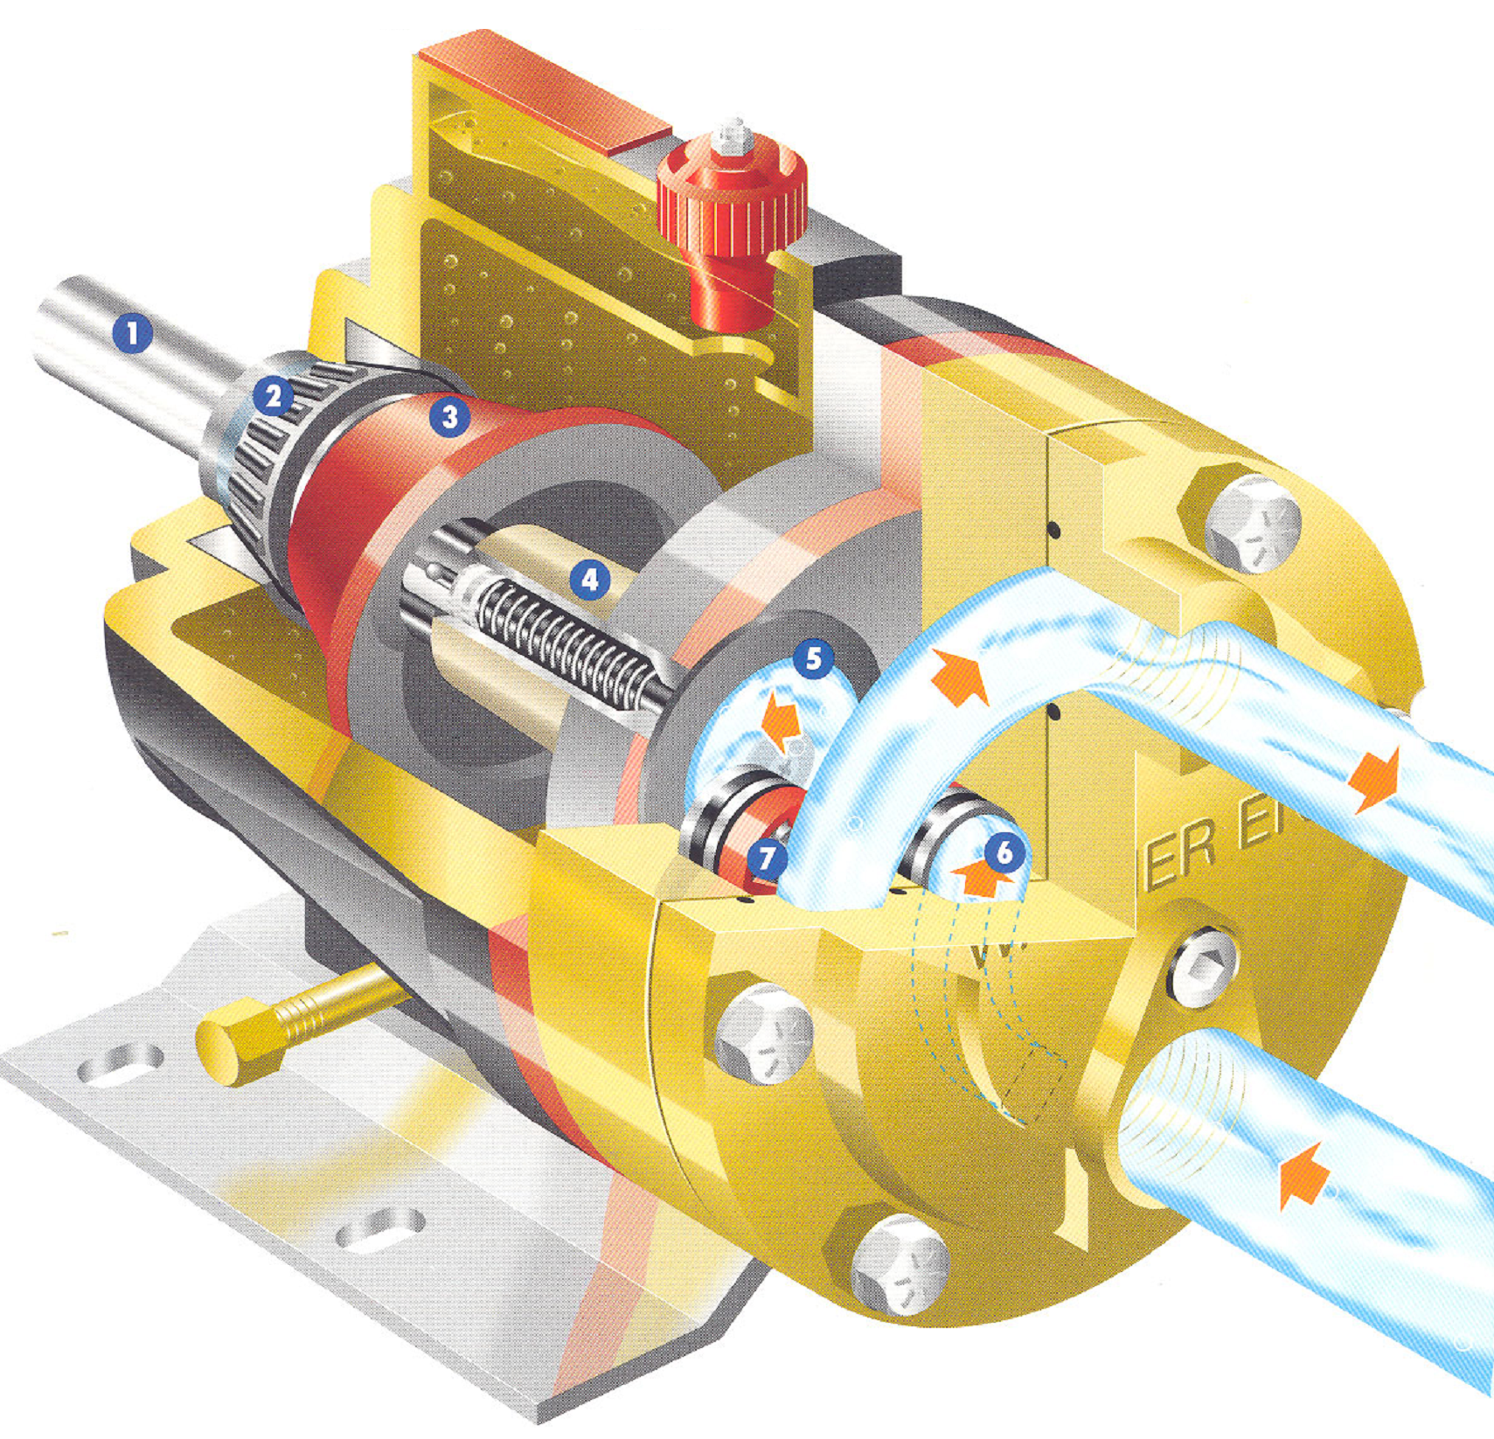
9332 North 95th Way  Scottsdale, AZ 85258  Phone:480-998-4097  sales@apewater.com | 