IMO Pump REPAIR PARTS KITS

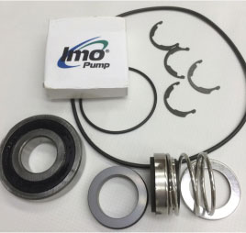 | Pump parts for  IMO D3EB-87/95 Pumps (p/n 3240/011)  - Minor Repair Kits contain basic common wear parts - seals, bearings, gaskets and o-rings.  - Major Repair Kits contain all wearing parts including all Minor Kit parts

D3EB-87/95 | MINOR KIT | 3240/011RA
Please note: Minor Repair Kits basic common wear parts - seals, bearings, gaskets and o-rings.
Quantity: | Part #: | Description:
1 ea. | PP500DCZ | * 13 POINT CUSTOM PRINT WARNING TAG
1 ea. | PP047BAC | * BEARING
1 ea. | PP028JA-50 | * RING RETAINING, BASIC EXTERNAL
1 ea. | PP028LA-50 | * RING TRUARC #5160-50
1 ea. | PP046JRF | * SEAL 0.500 RO POS DRIVE
1 ea. | S5323DF | * GASKET .015
1 ea. | PP056SB1-134 | * O-RING

PLEASE NOTE: There is no MAJOR Kit available for this pump.

9332 North 95th Way
Scottsdale, AZ 85258
Phone:480-998-4097
sales@apewater.com

