IMO Pump REPAIR PARTS KITS

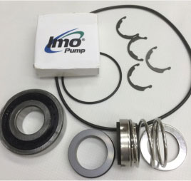 | Pump parts for  IMO C3EB-143/162 Pumps (p/n 3242/250)  - Minor Repair Kits contain basic common wear parts - seals, bearings, gaskets and o-rings.  - Major Repair Kits contain all wearing parts including all Minor Kit parts

C3EB-143/162 | MINOR KIT | 3242/250RA
Please note: Minor Repair Kits basic common wear parts - seals, bearings, gaskets and o-rings.
Quantity: | Part #: | Description:
1 ea. | PP047BM | * BEARING
1 ea. | PP028KA-78 | * RING, RETAINING, EXT.
1 ea. | PP046JKN | * SEAL 1.000 RO RBRBLW
1 ea. | PP056SB1-233 | * O-RING
1 ea. | PP056SB1-134 | * O-RING

PLEASE NOTE: There is no MAJOR Kit available for this pump.

9332 North 95th Way  Scottsdale, AZ 85258  Phone:480-998-4097  sales@apewater.com | 