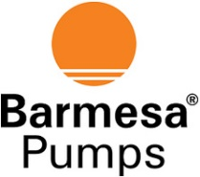 911 Seires ANSI Centrifugal Pump
PERFORMANCE CURVES
The BARMESA 911ANSI pump series are centrifugal process pumps with horizontal suction and vertical discharge, open impeller, which meets ANSI B73.1 requirements. It is made of the best materials and components, with continuous inspection, ensuring high quality – at competitive pricing.
