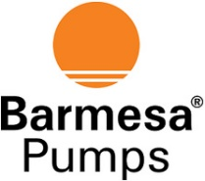 911 Series ANSI Centrifugal Pump
COMMON COOLING PLAN ARRANGEMENTS
A wide range of options at economical pricing.

